**Alphabet Soup Funding Analysis**

**Overview**: The purpose of the analysis is to set up a model to predict if applicants to Alphabet Soups’s charity funding will be successful.

**Results**: In Data Processing, I am using the target variable IS_SUCCESSFUL for my model and Using Application type, affiliation, classification, use_case, organization, status, income_amt, special_considerations, ask_amt for the features variables.

I also removed EIN and names since these are to identify and they don’t have many relations to what I have to do in the model.

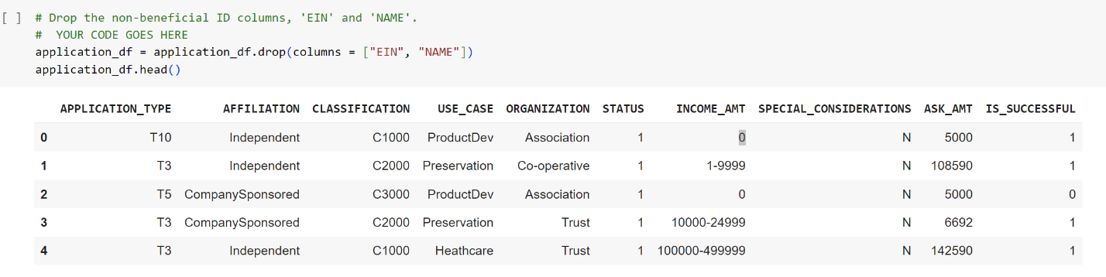

For the Compiling, Training and Evaluation section, I have select 2 hidden layers and the first hidden layers with 80 neurons and 30 on the second hidden layers with both ReLu activation functions and output layer as sigmoid.

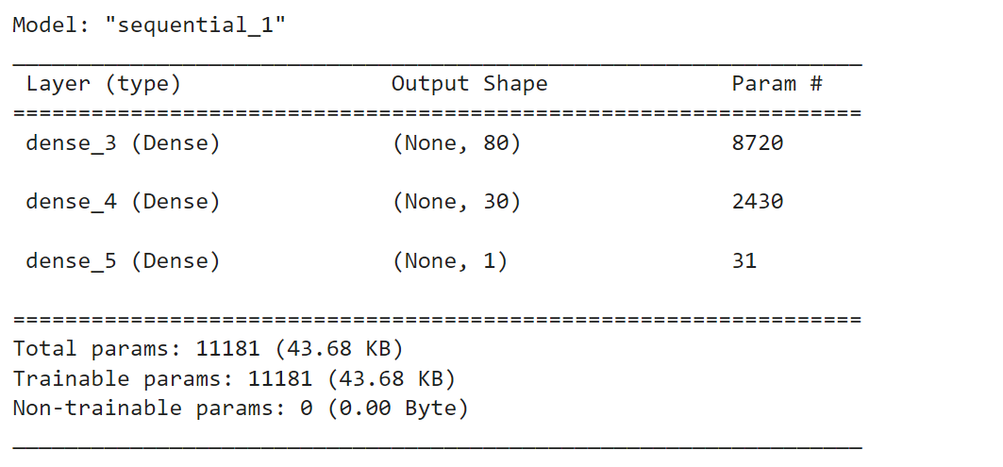

It came out with 72% accuracy which is not achieving the target model performance.



I have also tried to use other features variable and adjust the neuron to 8 for the first layer and 5 for the second layer. It also came out at 72% which is also not achieving the target model.

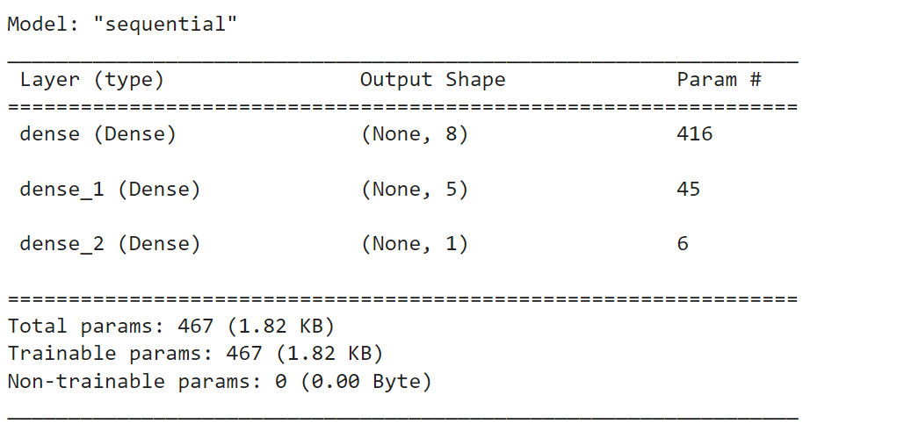



I also used h**yperparameter-tuned Deep Neural Network m**odel and using the “moon” dataset to optimize it and the result came out not bad around 96.8% which achieve the target model.

In Summary, I have tried a couple different attempts and use different model to figure the best fit model for Alphabet Soup Funding and the result of hyperparameter-tuned Deep Neural Network model came out with a good accuracy score.